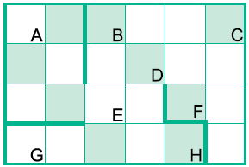

|  |  |  |  |  |  |  |  |  |
| --- | --- | --- | --- | --- | --- | --- | --- | --- |
| **Клетка**  **Утверждение** | **A** | **B** | **C** | **D** | **E** | **F** | **G** | **H** |
| сверху свободно |  |  |  |  |  |  |  |  |
| справа стена |  |  |  |  |  |  |  |  |
| снизу свободно |  |  |  |  |  |  |  |  |
| слева стена |  |  |  |  |  |  |  |  |
| клетка чистая |  |  |  |  |  |  |  |  |

